**GET PRODUCTION READY WITH SPRING BOOT – 1 – PROFILES**

* Applications have different environments: Dev, QA, Stage, Prod, ...
  1. Different environments **need different configuration**:
     1. Different Databases
     2. Different Web Services
* How can you provide different configurations for different environments?
  1. **Profiles**: Environment specific configuration
* How can you define externalized configuration for your application?
  1. **ConfigurationProperites**: Define externalized configuration.

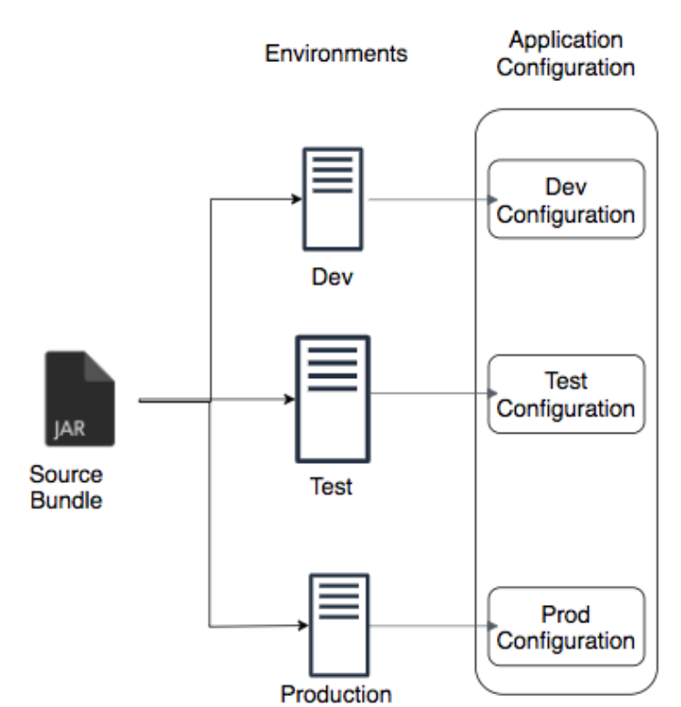

application-dev.properties

logging.level.org.springframework=trace

application-prod.properties

logging.level.org.springframework=info

application.properties

logging.level.org.springframework=debug

Here, in the above example, we have different logging configuration for different profiles.

**FOR EXAMPLE**

**What is logging?**

Logging is the process of generating and storing records of events that occur in a software application or system. These records, called log entries or log messages, capture information about the execution of the application or system, such as errors, warnings, informational messages, and debugging information.

Logging is a crucial aspect of software development, maintenance, and troubleshooting, as it provides valuable insights into the behaviour of the application or system, allowing developers and administrators to identify and diagnose issues, track down bugs, and monitor performance.

Logging is typically implemented using a logging framework, which provides a standardized way of generating and storing log messages, as well as configuring the level of detail and the destination of the log output. Common logging frameworks in Java include Log4j, Logback, and JDK logging.

**Logging level:**

1. Trace – All the levels below it, everything will be printed.
2. Debug – Debug, Warning, Error will be printed.
3. Warning – Warning and Error will be printed.
4. Error – Error will be printed.
5. Off